
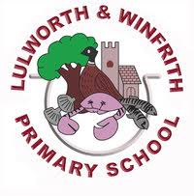
Who receives the Pupil Premium?
Funding Criteria | Amount per Pupil (Primary)
Eligible for free school meals (FSM) or FSM in the past 6 years (Ever 6) | £1,515
Previously looked after by a local authority or other state care (PLAC) | £2,630
Currently looked after by the local authority (LAC) | £2,630
Children of service families (Service Pupil Premium) | £350

🏫 Who Receives the Funding
- Schools receive funding for FSM and PLAC pupils.
- Local Authorities receive funding for LAC pupils and decide how much to pass on to schools.
- Service Pupil Premium is paid directly to schools for eligible pupils.

📋 Eligibility Notes
- PLAC includes children adopted from state care or equivalent from outside England and Wales.
- LAC funding must be used to improve attainment and follow the DfE’s “menu of approaches”.
- Service children must be registered in the school census as having a parent in the armed forces or meet other qualifying criteria.[2]
Would you like this information formatted into a printable table or slide for your classroom or staff briefing?
References
[1] Pupil Premium | Greave Primary School
[2] Pupil premium: conditions of grant for the 2025 to 2026 financial year

What is the Pupil Premium?
The Pupil Premium is extra funding that the government gives to schools for each pupil considered to be ‘disadvantaged’. Pupil Premium funding allows schools to target additional support for children and ensure that they do not fall behind their peers. The Department of Education website is a good source of further information:
Pupil Premium Information

LULWORTH & WINFRITH PRIMARY SCHOOL
Find more info on the school website!




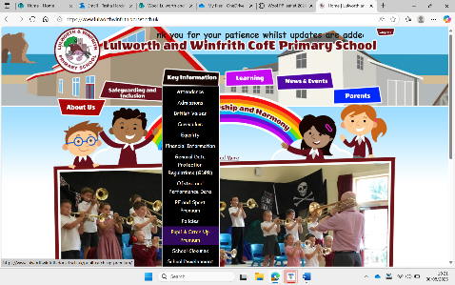
Information for Families 2025/26
BELIEF, FELLOWSHIP and HARMONY
How do we spend Pupil Premium funding?
- Staff training and resources to provide high quality teaching
- TA time and resources to deliver interventions and small group phonics, maths and English sessions.
- Weekly sports (KS2) and forest school lessons (KS1), which enable the teacher to run conferencing ‘catch-up’ sessions.
- Small group tutoring in maths and English.
- Pastoral support through ELSA and check-in sessions.
- Half a term of an extra-curricular club after school


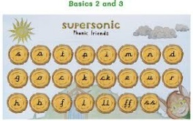
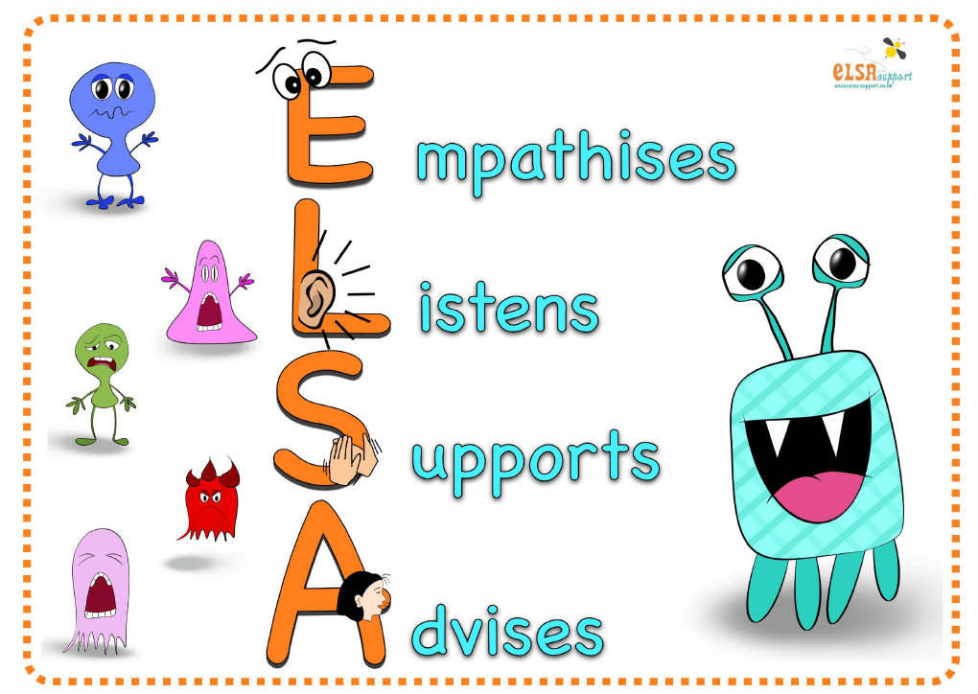

Did you know, children who receive Pupil Premium funding are entitled to:
Free hot school meals

Free uniform items bearing the school logo
Discount on the residential trips!
Half a term of extra-curricular club offer taking place after school.
What is the Service Premium?
The Service Premium is a separate grant for pupils who have a parent serving in the armed services. Unlike the Pupil Premium, this grant is not solely for raising attainment but for providing additional support (mainly pastoral)
Service Pupil Premium: what you need to know - GOV.UK

