Where to go for more information

Contact the school
If you have any questions or concerns about the Prevent Strategy and what it means for your child, please do not hesitate to contact the school office:
Lwps.office@coastalpartnership.co.uk

See our policies
You will find more details about radicalisation in our safeguarding policy, available on our website.
We also have information about spiritual, moral, social and cultural development and British
values on our school website.
www.lulworthwinfrith.dorset.sch.uk

External sources
The following sources may also be useful for further information:
Prevent duty guidance: for England and Wales, HM Government
Prevent duty guidance: England and Wales (2023) - GOV.UK
Frequently asked questions, Prevent For Schools
Prevent - BCP Safeguarding Children Partnership and the Dorset Safeguarding Children Partnership
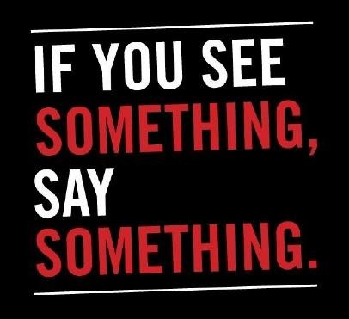

The Prevent S
trategy

Safeguarding Team

Members



Prevent Lead

Mrs Griffiths
Designated Safeguarding Lead & Headteacher




Mrs Griffiths, DSL Miss Hardy
Deputy, DSL/SENDCo DSL Assistant Head/DSL


What is the Prevent strategy?

KEY TERMS

Extremism

–

vocal or active opposition

to fundamental British values such as democracy, the rule of law
and tolerance of different faiths and beliefs

Ideology

–

a set of beliefs

Terrorism

–

a violent action against people or property, designed to create fear and advance a political,
religious

or ideological cause

Radicalisation

–

the process by which a person comes to support extremism and terrorism

We will give

children the skills to protect them from any
extremist views they may encounter, now or later in their lives.
Prevent is a government strategy designed to stop people becoming terrorists or supporting terrorist or extremist causes.
The Prevent strategy covers all types of terrorism and extremism, including the extreme right wing, violent Islamist groups and other causes.
How does the Prevent strategy apply to schools?
From July 2015 all schools (as well as other organisations) have a duty to safeguard children from radicalisation and extremism.
This means we have a responsibility to protect children from extremist and violent views the same way we protect them from drugs or gang violence.

What does this mean in practice?
Many of the things we already do in school to help children become positive, happy members of society also contribute to the Prevent strategy.
These include:
Most importantly, we can provide a safe place for pupils to discuss these issues so they better understand how to protect themselves.

- Exploring other cultures and religions and promoting diversity
- Challenging prejudices and racist comments
- Developing critical thinking skills and a strong, positive self-identity
- Promoting the spiritual, moral, social and cultural development of pupils, as well as British values such as democracy
We will also protect children from the risk of radicalisation, for example by using filters on the internet to make sure they can’t access extremist and terrorist material, or by vetting visitors who come into school to work with pupils.
Different schools will carry out the Prevent duty in different ways, depending on the age of the children and the needs of the community.

Frequently Asked Questions
How does Prevent relate to British values?
Schools have been required to promote British values since 2014, and this will continue to be part of our response to the Prevent strategy.
British values include:
- Democracy
- The rule of law
- Individual liberty and mutual respect
- Tolerance of different faiths and beliefs
Isn’t my child too young to learn about extremism?
The Prevent strategy is not just about discussing extremism itself, which may not be appropriate for younger children. It is also about teaching children values such as tolerance and mutual respect.
The school will make sure any discussions are suitable for the age and maturity of the children involved.
Is extremism really a risk in our area?
Extremism can take many forms, including political, religious and misogynistic extremism. Some of these may be a bigger threat in our area than others.

