
Lulworth Primary School
Safeguarding Information

Your Designated Safeguarding Lead for Child Protection is:

Miss N Hardy
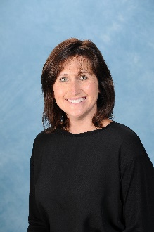

The Deputy Designated Safeguarding Leads for Child Protection are:


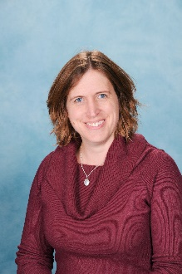

Mrs E Griffiths Mr M Leeming Miss H Stopforth
Dorset LADO Team - Martha Sharp, Lynne Bowman and Laura Tulk 01305 221122

If you have a child protection concern, then please talk to one of the above members of staff.

Don’t think ‘What if I am wrong?’…..think ‘What if I am right?’

