
Lulworth and Winfrith Primary School Safeguarding Information

Your Designated Safeguarding Lead for Child Protection is:
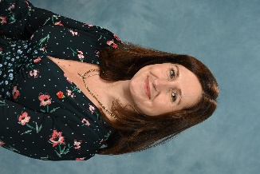

Miss N Hardy

The Deputy Designated Safeguarding Leads for Child Protection are:
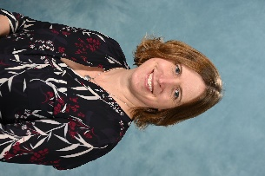

Mrs E Griffiths Mrs L McHarg
LADO - Martha Sharp
Supporting LADO – Lynne Bowman
01305 221122
If you have a child protection concern, then please talk to one of the above members of staff. Don’t think ‘What if I am wrong?’…..think ‘What if I am right?’

